[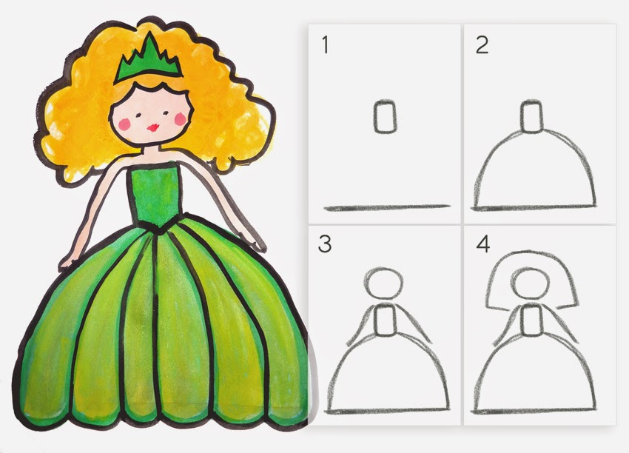](http://2.bp.blogspot.com/-tjO3_TiPUBE/U1xxhzSSrGI/AAAAAAAAA2I/fVHlbm15yXk/s1600/princess.jpg)