[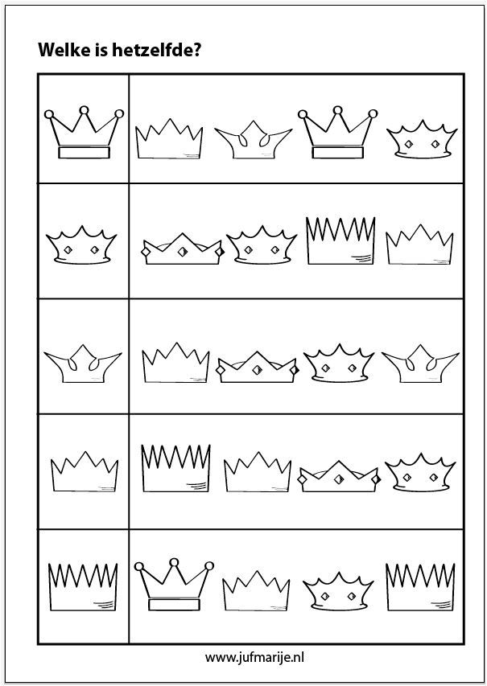](https://www.google.com/url?sa=i&url=https%3A%2F%2Fwww.pinterest.com%2Fpin%2F335166397245989540%2F&psig=AOvVaw37nX-t776Bx3UWGRDA8iAl&ust=1588233708407000&source=images&cd=vfe&ved=0CAIQjRxqFwoTCIi_nuaVjekCFQAAAAAdAAAAABA1)