[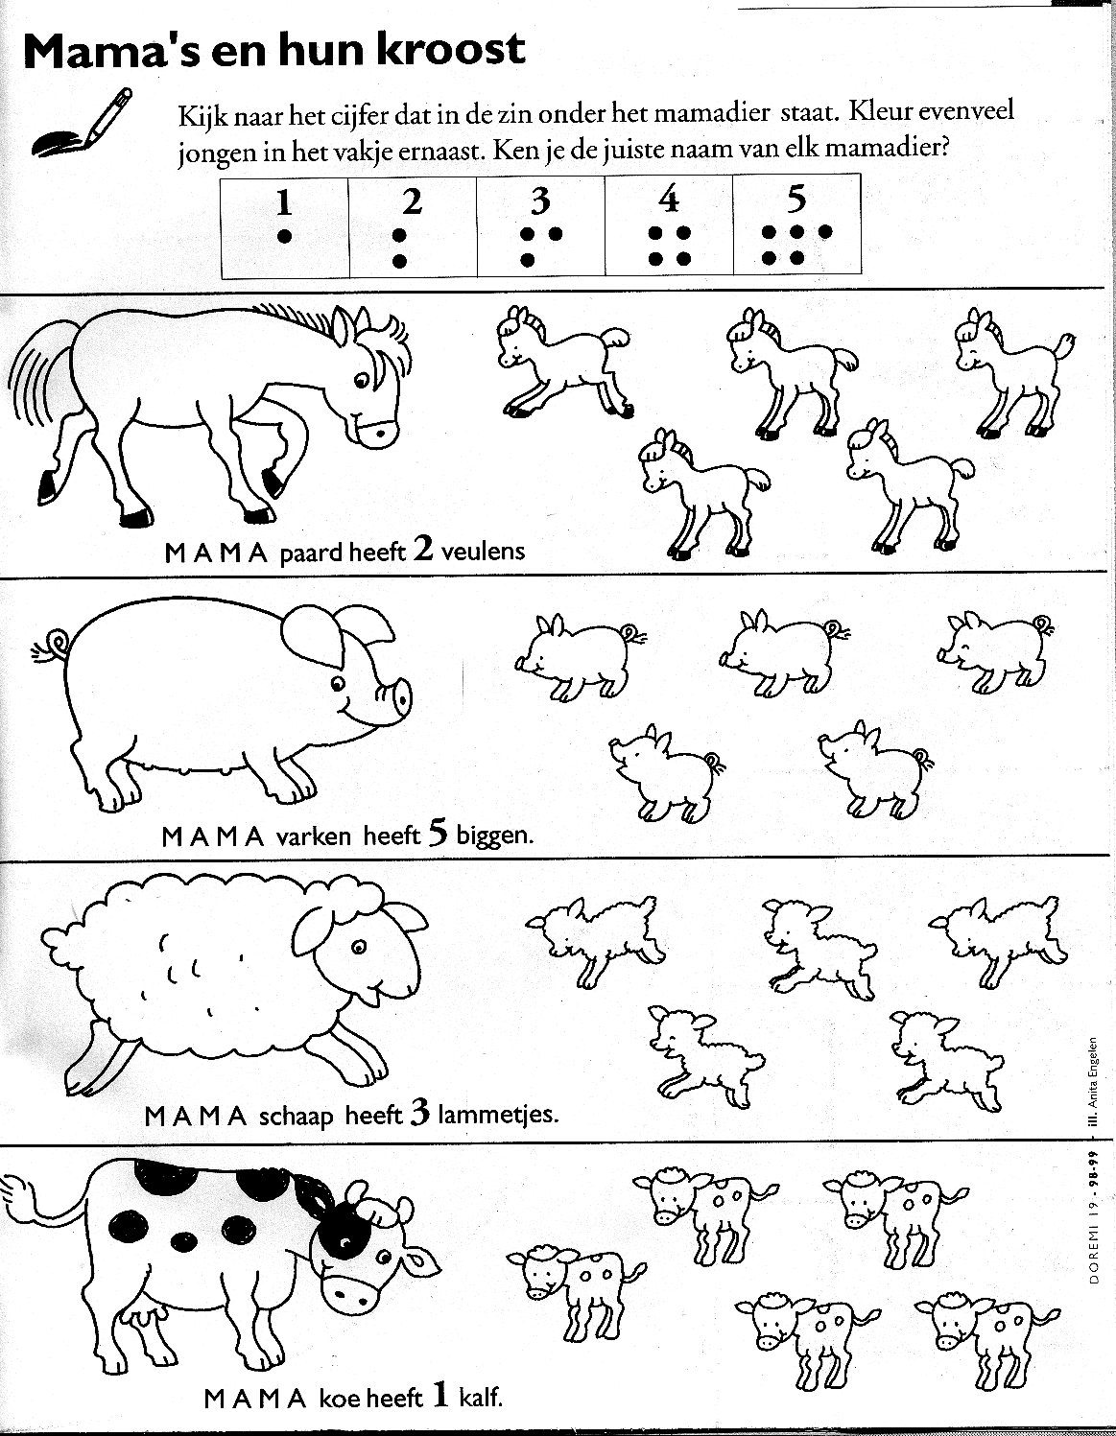](https://www.google.com/url?sa=i&url=https%3A%2F%2Fwww.kleutergroep.nl%2FLente%2Findex%2520werkbladen%2520lente.htm&psig=AOvVaw1brf5RVZjxINH7CAtoqNII&ust=1587659873490000&source=images&cd=vfe&ved=0CAIQjRxqFwoTCLD12Ym8_OgCFQAAAAAdAAAAABAD)