[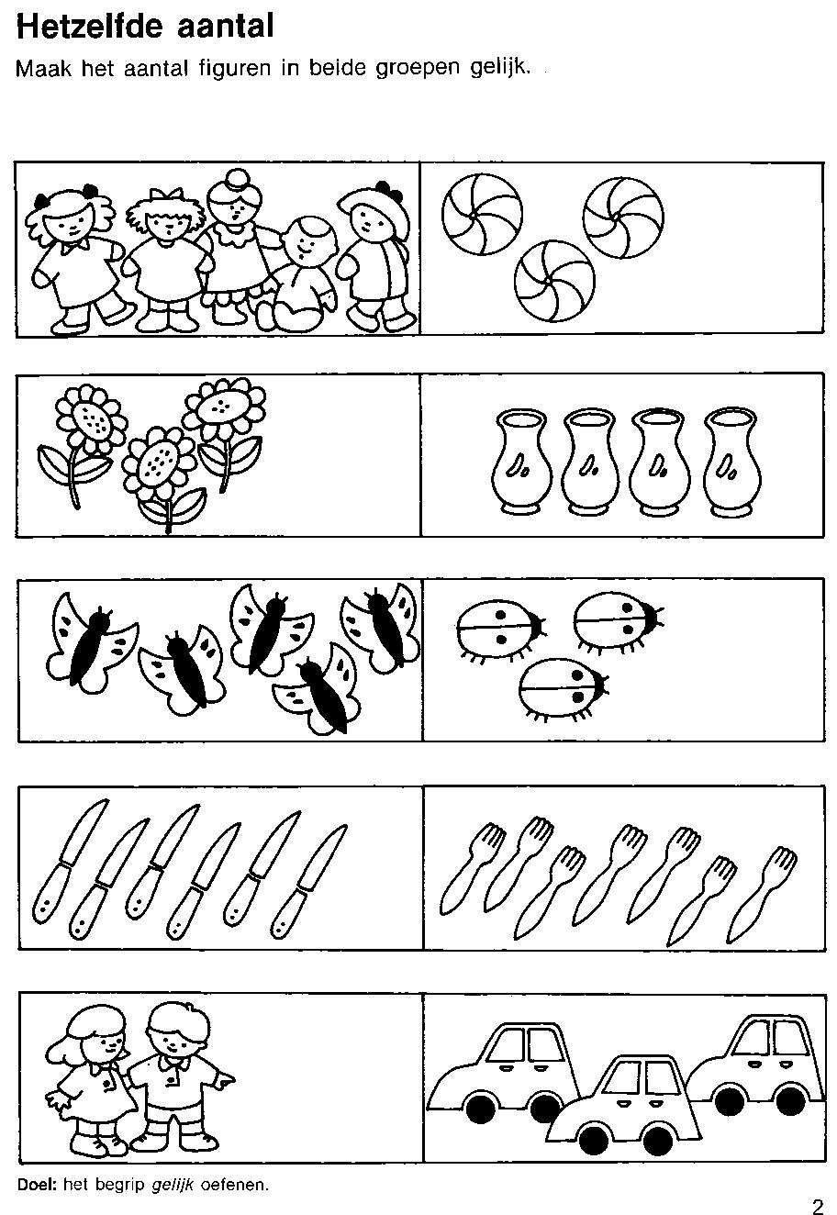](https://www.google.com/url?sa=i&url=https%3A%2F%2Fwww.kleutergroep.nl%2FRekenkennis%2Fwerkbladen%2520rekenen%2520index.htm&psig=AOvVaw3oG37_3ilIxhj-X3ds4q5J&ust=1587659426912000&source=images&cd=vfe&ved=0CAIQjRxqFwoTCKie8ba6_OgCFQAAAAAdAAAAABAK)