[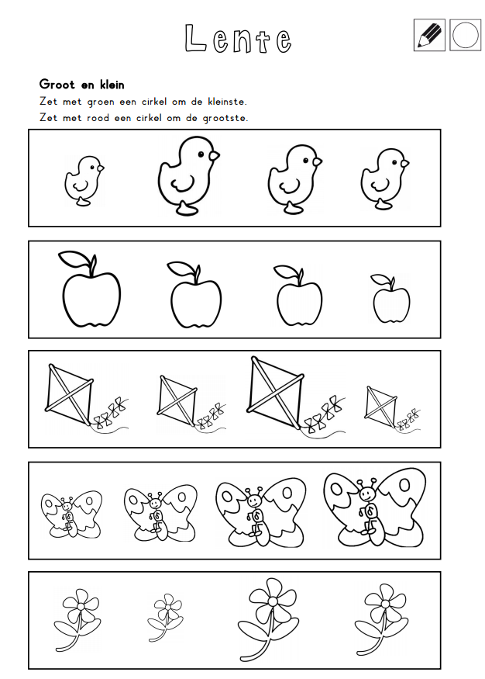](https://www.google.com/url?sa=i&url=https%3A%2F%2Fnl.pinterest.com%2Frehobothurk%2Flente-werkbladen-kleuters%2F&psig=AOvVaw2a60FLROuWcKxgYRGhxP6l&ust=1587659697234000&source=images&cd=vfe&ved=0CAIQjRxqFwoTCJCVxLa7_OgCFQAAAAAdAAAAABAK)